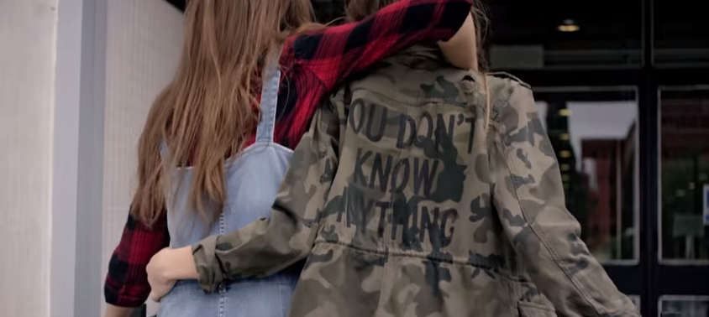
Click here to see the video

‘BACK TO SCHOOL’ WITH BERSHKA

VARSITY RENEWAL, PRINTED MESSAGES AND OVERLAPPING LAYERS ARE THE KEY GARMENTS IN BERSHKAS NEWEST COLLECTION FOR BSK.

Bershka’s youthful look is inspired in the 90’s university trends: woodcutter shirts, oversize sweatshirts, layering, overalls, skater skirts and varsity jackets.

Easy to wear fabrics like plush and denim elastics give the Back to School collection a comfortable and cozy feel. Iconic garments like the military parka are renewed with vindictive messages taken from the digital language used in social media. Since The Back to school collection aims to appeal to Bershka’s younger aged public, it communicates with them in through messages they can relate to.

Plus a Mickey Mouse license is used on some sweaters and t-shirts.
Discover the collection here. For more visit www.bershka.com

More info at:

press.bershka.com

